Code:

#Paint Data  
colours = ['Swiss Coffee', 'Polar Bear', 'White', 'Frost', 'Whisper White', 'Vibrant White', 'Ultra Pure White', 'Cameo White']  
  
categories = ['Interior', 'Exterior']  
  
interior_use_combo = {'Flat (0-4% sheen)': 'Used for dining room and ceiling. Minimizes surface imperfections and delivers excellent touch-up.',  
 'Matte (3-10% sheen)': 'Used for bedrooms and family rooms. Provides a durable stain and scuff resistant finish.',  
 'Eggshell (10-25% sheen)': 'Used for bedrooms, kids rooms, and hallways. Resists dirt and grim; ideal for active households.',  
 'Satin (20-35% sheen)': 'Used in kitchen and bathroom. All-surface finish delivers durable protection and moisture resistance.',  
 'Semi-gloss (40-65% sheen)': 'Used for trim, doors, cabinets, tables. Extremely durable; resists stains, moisture and wear.',  
 'High Gloss (>85% sheen)': 'Used for trim, doors, cabinets, tables. Maximum durability against moisture, dirt and grime.'}  
  
interior_projects_rule = {'Bedroom': '2 gallons',  
 'Hallway': '1 gallon',  
 'Ceiling': '1 gallon of the ceiling paint',  
 'Kitchen': '2 gallons',  
 'Bathroom': '1 gallon for a small bathroom',  
 'Trim': '1 quart per room',  
 'Accent Wall': '2 quarts'}  
  
exterior_use_combo = {'Flat (0-3% sheen)': 'Typically used for walls, siding, masonry, and wood. Minimizes surface imperfections and delivers excellent touch-up.',  
 'Satin (20-30% sheen)': 'Typically used for siding, trim, fences, and sheds. All-surface finish delivers durable protection and moisture resistance.',  
 'Semi-gloss (40-65% sheen)': 'Typically used for doors, garage doors, trim, and shutters. Extremely durable; resists stains, moisture and wear.',  
 'High Gloss (>85% sheen)': 'Typically used for doors, trim, shutters, and fences. Maximum durability against moisture, dirt and grime.'}  
  
exterior_projects_rule = {'shed': '1 gallon',  
 '1-car garage': '2 quarts',  
 '2-car garage': '1 gallon',  
 'siding of entire house': 'at least 5 gallons to start'}  
  
sizes_coverage = {'1 Sample size/tester (237 mL)': '25 square feet (good enough for touch ups)',  
 '1 Quart (1 L)': '100 square feet (good enough for two coats on one wall (accent wall), a single door (both sides), or a to paint the trim and baseboards of a room',  
 '1 Gallon (3.79 L)': '400 square feet (2 gallons would be enough for two coats of an average sized bedroom or a two car garage door',  
 '5 Gallon (18.9 L)': '2,000 square feet'}  
  
product_line = {'1': 'Premium Plus, $45 per gallon; Exceptional durability and hide with a finish that resists mildew and stains',  
 '2': 'Ultra - Scuff Defense, $60 per gallon; Scuff and mar resistant finish, antimicrobial, outstanding durability, stainblocking',  
 '3': 'Marquee, $80 per gallon; One coat hide, advanced stain-blocking, stain repellant, scrubbable easy clean finish, superior durability',  
 '4': 'Dynasty, $95 per gallon; One coat hide, Stain-blocking, Stain repellant, scuff and mar resistant, fast drying, advanced durability'}  
  
#Introduction  
print()  
print("Hello, I am here to help you buy paint today. I will need to ask you 5 different questions to help you find the right paint for your paint project. ")  
print()  
  
#Colour choice  
colour_choice=input("Have you chosen a colour? Please provide us with the name of the colour. ")  
print()  
  
#Interior or Exterior  
category=input("Great, that's a good choice of colour! Is this paint project for interior or exterior? ")  
print()  
  
#Choosing Sheen  
print("\t",category.capitalize(),"paint is available in the following sheens (ordered by lowest sheen to highest sheen). The term 'sheen' means level of shine, also known as the enamel.")  
print("\t The higher the sheen the more durable and easier to clean the paint will be:")  
print()  
if category == "interior":  
 for key in interior_use_combo:  
 print(key, interior_use_combo[key], sep=": ")  
else:  
 for key in exterior_use_combo:  
 print(key, exterior_use_combo[key], sep=": ")  
print()  
sheen_choice=input("Please choose a sheen: ")  
print()  
  
#Choosing the quantity of paint (try to find out what is the square footage in order to estimate how much paint will be required)  
print("\tOkay we're almost there. Now I need to determine how much paint you will need.\n\t")  
print("\tPaint coverage refers to how much area one single coat of paint will cover.\n\tThis is just an estimate and will also depend on how heavy you are putting on the paint and what quality of paint you are purchasing.")  
print("\tIt is generally recommended to use two coats of paint unless you are using a One-Coat Hide Colour with either Marquee or Dynasty Paint")  
print()  
print("Below is some general information regarding paint sizes available and the total coverage for each.\nKeep in mind that 2 quarts of paint is almost the same price as a gallon so you may want to just go for the gallon if you aren't sure if two quarts is enough.")  
for key in sizes_coverage:  
 print(key, sizes_coverage[key], sep=": ")  
print()  
quantity_choice=input("Please choose one of the following options by entering number 1,2,3, or 4:\n 1. Enter the total square footage of the project you are working on.\n 2. Enter the amount of paint you want to buy today (example: 1 gallon of paint)\n 3. Calculate square footage of room\n 4. Show me the how much paint I need based on a list of common projects.\n ")  
  
if quantity_choice == '1':  
 sqrft=input("Please enter the square footage of the project you are painting: ")  
 if int(sqrft) <= 100:  
 print("You will need 2 quarts of paint.")  
 elif int(sqrft) <= 200:  
 print("You will need 1 gallon of paint.")  
 elif int(sqrft)<2000:  
 print("You will need ",int(sqrft)/400*2, " gallons of paint.")  
 elif int(sqrft)>=2000:  
 print("You will need ",int(sqrft)/2000*2, " 5 gallon pail(s) of paint.")  
  
elif quantity_choice == '2':  
 known_qty=input("Please enter how much paint you need today: ")  
  
elif quantity_choice == '3':  
 height=input("What is the height of ceilings? Most ceilings are 8 feet high: ")  
 length=input("What is the length of room? Most rooms are 12 feet long: ")  
 width=input("What is the width of the room? Most rooms are 10 feet wide: ")  
 x = (int(height)*int(length)*2)+(int(height)*int(width)*2)  
 print("The square footage of your room is", x, "square feet (not including windows, doors and trim)")  
 known_qty=input("Okay then, for the room you are painting you will need "+str(round((x/400)*2))+" gallons of paint. Please enter Y or N to proceed: ")  
  
elif quantity_choice == '4':  
 if category == "interior":  
 for key in interior_projects_rule:  
 print(key, interior_projects_rule[key], sep=": ")  
 else:  
 for key in exterior_projects_rule:  
 print(exterior_projects_rule[key], sep=": ")  
  
  
  
#Choosing product line  
print()  
print("This is the last question. In terms of quality of paint, Behr has 4 kinds of paint & primer in one paints.")  
print()  
for key in product_line:  
 print(key, product_line[key], sep=": ")  
  
product_line_choice=input("Please enter 1,2,3, or 4: ")  
print()  
print("Thanks! I will mix the paint for you now. It will be ready in 5 minutes. In the meantime, please feel free to shop around!")

Output:

Scenarios:

1. Buying **interior** paint and we know the dimensions of the room we are painting but need a little help **calculating** how much paint we will need (option 3):

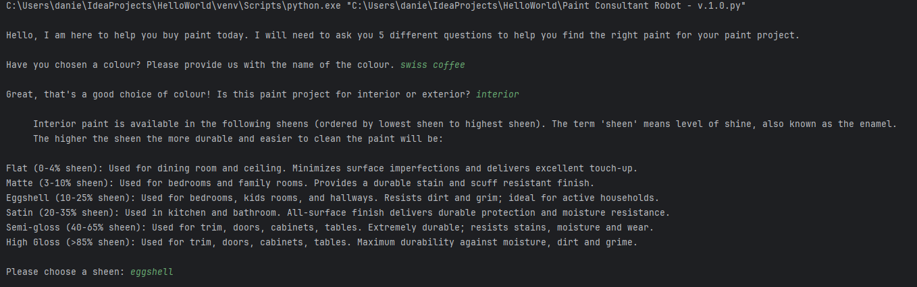

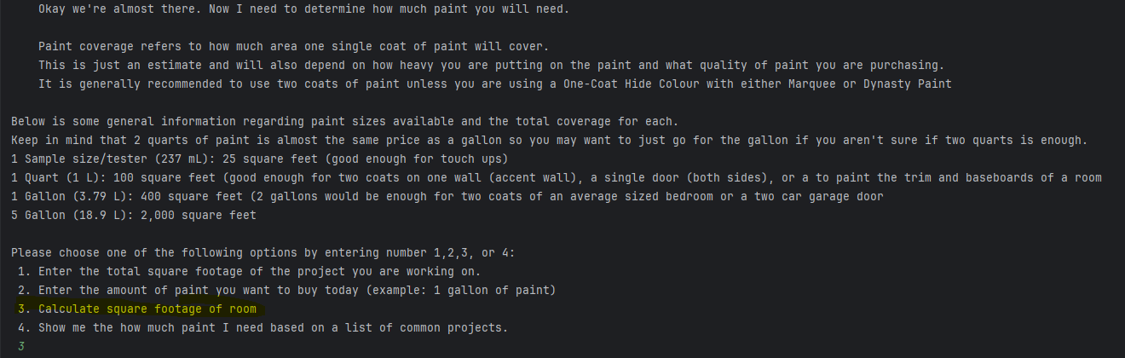

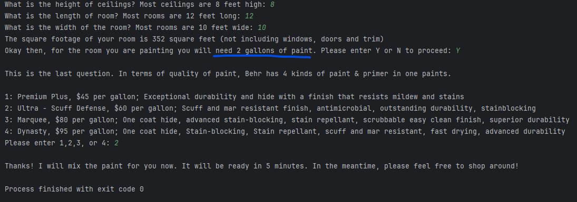

1. Buying **exterior** paint and we already know the total square footage of the area we are painting and just need to know **how much paint** we will need (option 1):

